### Jan Jugueta FOAR705 Learning Journal

**Week 2**

**8/8/19 - 3:20pm**

As part of last weeks homework, we were tasked to restore a file from 6 months ago. As I am a Mac user, I have been using Time Machine (sorry, not sorry) for my back ups. I have decided to restore a .pdf file of a CV I made at the start of the year.

Objective: Restore Jan_Jugueta CV.pdf file from Time Machine back up.

Action:

* Open Time Machine app.
* Selected 19/1/19 as the date.
* Opened Documents folder.
* Opened Personal folder.
* Selected Jan_JuguetaCV.pdf file.
* Clicked Restore.
* Selected option to Restore file to the Personal folder on my machine.

Error: None

Result: Restored Jan_JuguetaCV.pdf file to Documents/Personal/

**10/8/19 - 4:18pm**

I have decided to maintain my Learning Journal directly on Cloudstor so it will give me the ability to work on multiple machines with ease.

**11/8/19 - 12:16pm**

Having looked at my repository on the GitHub website again, I have decided to delete my ‘Jugueta-Exercises’ repository to start another one. This is because I have uploaded random files to the repository as a test, and now that I have a better understanding of what it is used for, I would rather it not be cluttered with unrelated data.

Objective: Delete ‘Jugueta-Exercise’ repository and start a new repository with the same name ‘Jugueta-Exercise’

Action:

* Clicked on the Settings button in the ‘Jugueta-Exercises’ repository page.
* Clicked on ‘Delete this repository’.
* Typed in the name of the repository ‘Jugueta-Exercises’ to confirm delete action.
* Entered GitHub password to confirm deletion.
* Clicked on the + symbol and selected New Repository.
* Named repository ‘Jugueta-Exercises’.
* Selected to keep the repository Public.
* Initialized the repository with a README.
* Clicked Create Repository.

Error: None

Result: Deleted old repository ‘Jugueta-Exercises’ and replaced it with a new repository with the same name.

**11/8/19 - 12:28pm**

Working through the Introduction lesson on Data Carpentry. Currently working on part 1, Formatting data tables in spreadsheets. The messy data from the lesson has been downloaded and is stored in the FOAR705/Files/Data Carpentry/Introduction folder on my machine.

As advised by the lesson, I will not alter the original data and instead create a new tab to work on.

Objective: Create new data tab in Excel workbook.

Action:

* Open SAFI_messy.xlsx file with Excel.
* Create new tab by pressing the + symbol at the bottom of the screen.
* Renamed new tab ‘DC Exercise’.

Error: None

Result: New tab created named ‘DC Exercise’.

**11/8/19 - 12:48pm**

Upon reviewing the SAFI_messy.xlsx file, a few things stand out and need to be ordered in the new tab:

* The Livestock table in the Mozambique tab contains multiple pieces of data in one cell.
* Inconsistent naming of things (i.e. mabati_sloping and mabatisloping).
* The Tanzania tab has no Plot table
* Inconsistency when using ‘null’ and ‘false’ across both tabs.
* Some blanks in cells. Unsure if they are ‘null’ values or have not yet been recorded.
* Using cell highlighting in one tab to indicate additional information.
* Using the * character to indicate additional information.
* Inconsistent text/number align in the cells.

To get in the habit of constantly committing data to GitHub, I will commit the edited SAFI_messy.xlsx file to GitHub. This version will have the newly created tab DC Exercise.

Objective: Commit SAFI_messy.xlsx file to GitHub

Action:

* Selected Upload files in the Jugueta-Exercises repository in GitHub.
* Dragged and dropped the SAFI_messy.xlsx file from my machine to the upload window in GitHub.
* Added the description ‘DC Introduction exercise’ to the upload.
* Added the extended description ‘Edited SAFI_messy.xlsx file with new DC Exercise tab.’
* Clicked on Commit changes.

Error: None

Result: Uploaded SAFI_messy.xlsx file to Jugueta-Exercises repository in GitHub.

**11/8/19 - 1:24pm**

Finished reading the Metadata section in Formatting data tables in Spreadsheets. Two key points from this section are:

* Metadata should not be stored with the data itself. It should be a separate file itself stored in the same directory.
* Metadata will help inform you, or other researchers about the data and data collection.

As part of the Metadata exercise, I have downloaded the SAFI_clean.csv file from the website and have moved it to FOAR705/Files/Data Carpentry/Introduction.

**11/8/19 - 1:50pm**

Having opened and read the contents of the SAFI_clean.csv file, my questions surrounding the file’s potential metadata are as follows:

* What does ‘no_membrs’ actually mean? Number of village members? Family members?
* Is ‘years_liv’ referencing the age of the interviewee? If not, then what?
* What does ‘affect_conflicts’ mean?
* What constitutes as an item in the ‘items_owned’ question?
* I assume ‘no_meals’ means number of meals, but is it referencing to daily meals, weekly meals or something else?

**11/8/19 - 2:05pm**

To get into the habit of version control, I have decided to enable version control and back up a copy of this Learning Journal to GitHub.

As I will be performing this back up during the documentation of the process, the soon-to-be backed up version of this Learning Journal will not be able to document this process.

Objective: Download current version of Learning Journal and commit to GitHub.

Action:

* Select File in Cloudstor.
* Selected Download As > Docx (Word file).
* Downloaded ‘Jan Jugueta - Learning Journal.docx’ to Download Folder on my machine.
* Enter Jugueta-Exercises repository in GitHub.
* Select Upload files.
* Dragged and dropped ‘Jan Jugueta - Learning Journal.docx’ to upload window in GitHub.
* Added the description ‘Learning Journal’.
* Added ‘20190811 14:13’ in the extended description to indicate when the Learning Journal was from.
* Clicked on Commit changes.

Error: None

Result: Uploaded ‘Jan Jugueta - Learning Journal.docx’ to GitHub.

**Week 3**

**14/8/19 - 1:54pm**

I have continued with the Data Carpentry exercises, resuming with Data Organization in Spreadsheets for Social Scientists. Some general points that stood out to me that I had never considered before were:

* Use underscores (_) instead of spaces when entering data or naming things.
* Don’t start naming things with numbers.
* Differentiate between a null value and true zero values.
* Don’t put multiple tables on the same tab.
* Ask yourself if adding a new column to a table will achieve the same result as creating a new tab.

**14/8/19 - 2:14pm**

I have revisited the Learn LaTeX in 30 minutes guide and am now going to start with the Scoping Exercise.

Overall objective: Complete Scoping Exercise using Overleaf and committing the .pdf and .tex file to Cloudstor and the .pdf to iLearn.

Objective: Create new project in Overleaf

Action:

* Select New Project in Overleaf website
* Name new project ‘Scoping Exercise’

Error: None

Result: New .tex project titled Scoping Exercise in Overleaf.

**14/8/19 - 2:20pm**

Objective: Add title, author name and date to .tex file

Action:

* Changed \title{Scoping Exercise} to \title{FOAR705 - Scoping Exercise}
* Changed \author{Jan Jugueta - 44828020}
* Clicked on Recompile to view updated changes

Error: None

Result: Success. Renamed the default title and author to what I wanted.

**14/8/19 - 2:22pm**

I also note that there is an introduction that is part of the default new project. This is an example of a section in LaTeX. I think I’ll use the sections command to separate the different parts of this assignment.

Objective: Create sections for, Research Area, Jobs, Pains, Pain Relievers, Gains, Gain Creators.

Action:

* Changed \section{Introduction} to \section{Research Area}
* Added \section{Jobs}
* Added \section{Pains}
* Added \section{Pain Relievers}
* Added \section{Gains}
* Added \section{Gain Creators}
* Clicked on Recompile to view updated changes

Error: None

Result: Success. Created all the new sections.

**14/8/19 - 2:40pm**

Objective: See what happens when I start typing text between \section{Research Area} and \section{Jobs}.

Action:

* Typed a paragraph of information.
* Clicked on Recompile to view updated changes.

Error: None

Result: The information I had typed between \section{Research Area} and \section{Jobs} appeared as paragraph text in the Research Area section.

**14/8/19 - 2:56pm**

For the Jobs section, I want to experiment with the unordered lists and see how that works with LaTeX.

Objective: Create a list in LaTeX.

Action:

* Using the guide I copied and amended the script provided, and entered this:

\begin{itemize}

\item

\item

\item

\item

\item

\item

\item

\end{itemize}

* Typed information after every \item line.
* Clicked on Recompile to view updated changes.

Error: None.

Result: Dot points have appeared with the text that I have typed in after the \item command.

**14/8/19 - 3:08pm**

For the next section, I want to see how paragraphs work.

Objective: Use paragraphs in the ‘Pains’ section.

Action:

* Typed one paragraph underneath the \section{Pains} line.
* Created a blank line after that typed paragraph.
* Typed a new paragraph after the blank line.
* Clicked on Recompile to view updated changes.

Error: None.

Result: Separate paragraphs created in the Pains section.

**14/8/19 - 3:41pm**

I have finished filling out the content for my scoping exercise. I will now recompile it, save it and upload both the .tex and .pdf for submission.

Objective: Recompile .tex file and upload files for submission.

Action:

* Clicked on recompile.
* Reviewed the PDF preview to ensure quality control.
* Clicked on Download PDF.
* Renamed main.tex to jugueta_scopingexercise.tex.
* Went back to the Project page in Overleaf.
* Downloaded jugueta_scopingexercise.tex.
* Opened the Scoping Exercise submission folder in Cloudstor.
* Created Jan Jugueta Scoping Exercise in Scoping Exercise submission folder.
* Uploaded jugueta_scopingexercise.tex and Jan_Jugueta_Scoping_Exercise.pdf to Jan Jugueta Scoping Exercise folder.
* Uploaded Jan_Jugueta_Scoping_Exercise.pdf to iLearn.

Error: None.

Result: Success. Scoping exercise submitted and uploaded to Cloudstor and iLearn.

**14/8/19 - 4:00pm**

As part of this weeks homework, we were asked to consider problem data produced by our discipline. As I will be mainly work with historical documents, I find that records on sporting tables and match fixtures in East Germany to be wildly inconsistent. I had read the book *The People’s Game* which is a comprehensive historical account of football in East Germany. However, I had noticed that match records, and how they were display were generally inconsistent for varying seasons. The ‘cells’ in the columns and rows would often contain multiple data sets. Furthermore, they often used special characters to denote more information about a certain data set.

I’m not entirely sure if this example fits the problem data produced by our discipline, but very often, the Stasi (East German Secret Police) would leave lines of information blank when it came to citizens that displayed worrisome anti-socialist behaviours. I would equate this to a null value, which makes me question what information could have been recorded there?

**14/8/19 - 4:10pm**

Objective: Download current version of Learning Journal and commit to GitHub.

Action:

* Select File in Cloudstor.
* Selected Download As > Docx (Word file).
* Downloaded ‘Jan Jugueta - Learning Journal.docx’ to Download Folder on my machine.
* Enter Jugueta-Exercises repository in GitHub.
* Selected Upload files.
* Dragged and dropped ‘Jan Jugueta - Learning Journal.docx’ to upload window in GitHub.
* Added the description ‘Learning Journal’.
* Added ‘20190814 16:109’ in the extended description to indicate when the Learning Journal was from.
* Clicked on Commit changes.

Error: None.

Result: Success. Committed Learning Journal to GitHub.

**14/8/19 - 4:11PM**

Objective: Commit Scoping Exercise to GitHub.

Action:

* Uploaded Jan_Jugueta_Scoping_Exercise.pdf and jugueta_scopingexercise.tex to GitHub.
* Added ‘Scoping Exercise’ to description.
* Added ‘.pdf and .tex’ to extended description.

Error: None.

Result: Successfully committed Scoping Exercise to GitHub.

**18/8/19 - 11:41am**

Since I have completed the Scoping Exercise on Overleaf, I have decided to migrate my Learning Journal to Tex as well. So my next step is to transfer my Week 2 Learning Journal to Overleaf.

Objective: Transfer Learning Journal Week 2 to Overleaf.

Action:

* Opened new Overleaf Project.
* Titled the project Learning Journal Week 2
* Copied and pasted the information from Learning Journal Week 2 from the Cloudstor .docx file into the new Overleaf project.
* Used the itemise code to create bullet points where needed.
* Click on Recompile.

Error: Jan_JuguetaCV.pdf appeared as Jan*jugueta*CV.pdf.

Result: Copied most of the text successfully, but still need to figure out how to make the underscore ‘_’ character appear as an underscore.

**18/8/19 - 12:10pm**

Using the Overleaf guide, I managed to find out the solution to the underscore problem. For underscore to be displayed in normal text, it needs to be preceded by the character ‘\’.

Objective: Fix the underscore problem in Learning Journal Week 2 in Overleaf.

Action:

* Found every instance of where the underscore character appeared and entered the ‘\’ character in front of them.
* Clicked on recompile.

Error: None

Result: Successfully fixed the underscore problem. They are now displayed as normal text.

**18/8/19 - 12:18pm**

After fixing the underscore problem, I want to figure out how to create a blank vertical space anytime a new paragraph is created. Asking Billy from class, she was able to help me out with the codes:

* \setlength{\parindent}{0pt}
* \setlength{\parskip}{1em}

Objective: Reformat the .tex document so that it creates vertical blank spaces for new paragraphs, and so that the new paragraphs are not indented.

Action:

* Entered \setlength{\parindent}{0pt} in the preamble.
* Entered \setlength{\parskip}{1em} in the preamble.

Error: None.

Result: Successfully reformatted the .tex file.

**18/8/19 - 12:30pm**

Now that I am happy with the layout of the Learning Journal in Overleaf, I now needed to upload the .tex version of my Learning Journal to Cloudstor and commit a version to GitHub.

Objective: Create a new folder in Cloudstor to store the new .tex Learning Journals. Once done, upload and commit Learning Journals to Cloudstor and GitHub.

Action:

* Create new folder in the Learning Journal folder called JuguetaLearningJournal.
* Cut and pasted the Jan Jugueta - Learning Journal.docx file into JuguetaLearningJournal Folder.
* Downloaded the Learning Journal Week 2 PDF and .tex file from Overleaf.
* Created Week2 Folder in JuguetaLearningJournal in Cloudstor.
* Uploaded Learning Journal Week 2 .pdf and .tex files into Week2 folder.
* Committed the Learning Journal Week 2 .pdf and .tex files into GitHub.

Error: None.

Result: Successfully uploaded and committed PDF and Tex files to both Cloudstor and GitHub.

**18/8/19 - 9:20pm**

Started to read the Dates as Data lesson in Data Carpentry. Some important notes here:

* Storing dates in a single column is not best practice.
* Mac and PC have different dates from when they count their dates.
* Excel stores dates as integers.
* Regional variances could confuse data.
* It is best to record the date as three different data sets ie. Day, Month and Year.

**18/8/19 - 9:28pm**

Have downloaded the SAFI_dates.xlsx file from the Data Carpentry site. To comply with the advice given in earlier Data Carpentry lessons, I will duplicate the sheets to ensure the original data is not modified.

Objective: Create a copy of the DD_MM_YEAR tab.

Action:

* Right clicked on the DD_MM_YEAR tab and selected ‘Move or Copy’.
* Selected to create a copy of the DD_MM_YEAR tab.
* Renamed copied tab DD_MM_YEAR_copy.

Error: None.

Result: Success. New copy created.

**18/8/19 - 9:53pm**

Now to create new columns to extract the date data.

Objective: Create columns for the Day, Month and Year.

Action:

* Created three new columns.
* Entered the text ‘day’, ‘month’ and ‘year’ in the 1st cell of the new columns.

Error: None.

Result: Success. Created new columns for day, month and year.

**18/8/19 - 9:57pm**

Now to extract the individual day components from the ‘interview_date’ column.

Objective: Extract day component from the ‘interview_date’ column.

Action:

* Entered the function =DAY( ) into cell B2.
* Recoded the function in cell B2 to =DAY(A2) to reference the ‘interview_date’ column.
* Clicked and dragged the bottom right corner of cell B2 to cell B15 to re-appropriate the =DAY( ) function for their own specific cells.

Error: None.

Result: Success. ‘day’ column has extracted the day data from the ‘interview_date’ column.

**18/8/19 - 10:05pm**

Objective: Extract month component from the ‘interview_date’ column.

Action:

* Entered the function =MONTH( ) into cell C2.
* Recoded the function in cell C2 to =MONTH(A2) to reference the ‘interview_date’ column.
* Clicked and dragged the bottom right corner of cell C2 to cell C15 to re-appropriate the =MONTH( ) function for their own specific cells.

Error: None.

Result: Success. ‘month’ column has extracted the month data from the ‘interview_date’ column.

**18/8/19 - 10:11pm**

Objective: Extract year component from the ‘interview_date’ column.

Action:

* Entered the function =YEAR( ) into cell D2.
* Recoded the function in cell D2 to =YEAR(A2) to reference the ‘interview_date’ column.
* Clicked and dragged the bottom right corner of cell D2 to cell D15 to re-appropriate the =YEAR( ) function for their own specific cells.

Error: None.

Result: Success. ‘year’ column has extracted the year data from the ‘interview_date’ column.

**18/8/19 - 10:13pm**

Below is a screenshot of the updated SAFI_dates.xlsx file.

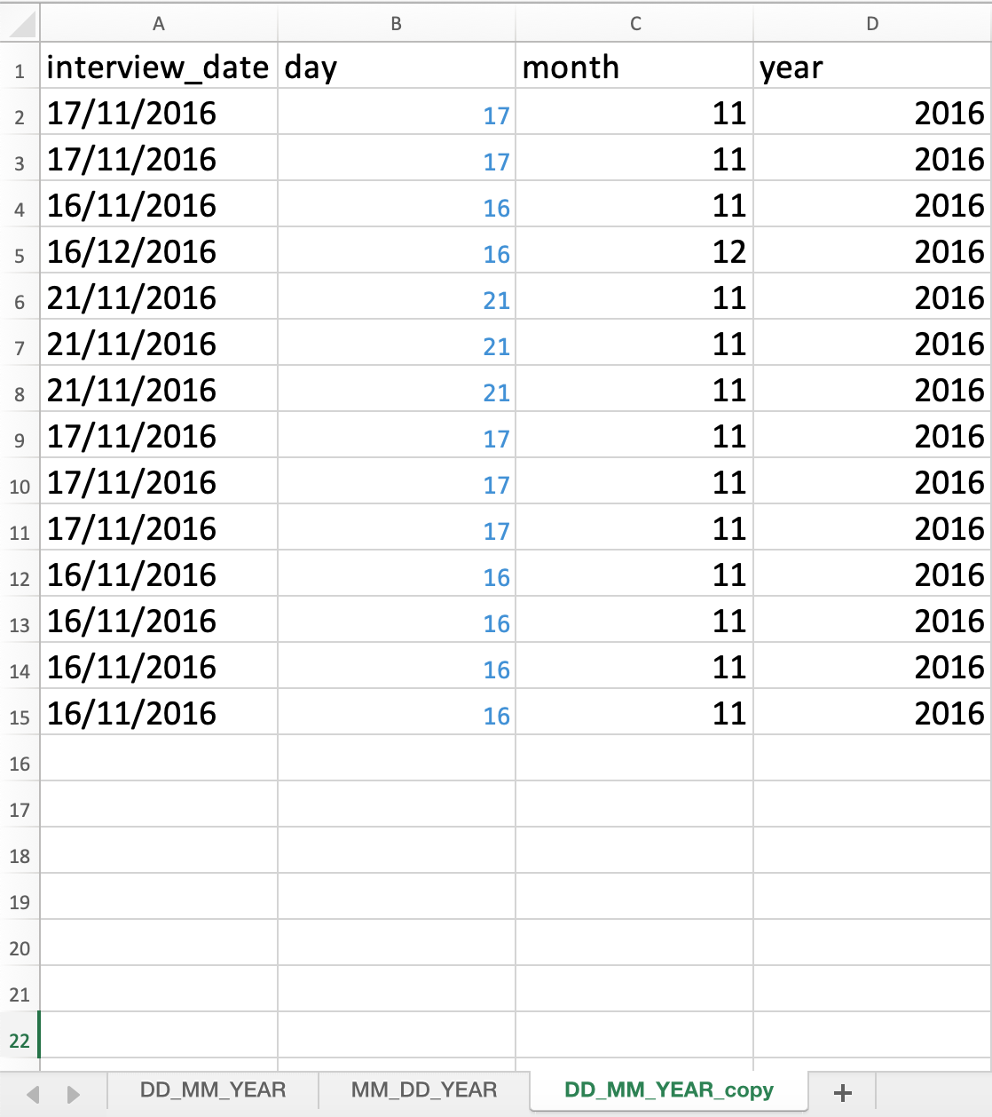

**18/8/19 - 10:16pm**

Following on to the next section of the exercise. I will now test adding 17/11 to the ‘interview_date’ column.

Objective: Add 17/11 to interview_date column.

Action:

* Entered 17/11 in cell A16.

Error: None.

Result: Cell B16 is displaying 17, cell C16 is displaying 11 and cell D16 is displaying 2019. Thus confirming that if no year data is entered, it will assume that the user implies the current year.



**18/8/19 - 10:53pm**

Because I want to include screen shots as part of this Learning Journal, I need to learn how to include images in LaTeX.

Objective: Add screenshots to Overleaf and use them in the Journal.

Action:

* Uploaded the screenshots to Overleaf.
* Renamed the two screenshots to ‘figa.png’ and figb.png’.
* Entered \usepackage{graphicx} to the preamble.
* Entered the code \includegraphics{figa.png}.
* Clicked on recompile to view updated changes.

Error: None, but display issues are present.

Result: The image loads, but it is poorly formatted for display.

**18/8/19 - 11:03pm**

I need to resize and position the image so that it fits the page better.

Objective: Resize and position the image for better display.

Action:

* Replaced \includegraphics{figa.png} with \includegraphics[width=\textwidth]{figa.png}
* Clicked on recompile to view updated changes.

Error: None.

Result: Success. Image displayed correctly.

**Week 4**

**19/8/19 - 11:50am**

New week. Time to upload and commit the Week 2 Learning Journal to Cloudstor and GitHub.

Objective: Upload and commit Week 2 Learning Journal to Cloudstor and GitHub.

Action:

* Downloaded Learning_Journal_Week_3.pdf from Overleaf.
* Downloaded LearningJournalWeek3 folder from Overleaf, which includes the .tex file and two .png images.
* Created Week3 Folder in 2019-FOAR705-Collaboration>Journals>JuguetaLearningJournal.
* Uploaded JuguetaLJWeek3.tex, figa.png and figb.png to Cloudstor.
* Uploaded Learning_Journal_Week_3.pdf to Cloudstor.

Error: None.

Result: Successfully uploaded and committed Learning Journal Week 3 to Cloudstor and GitHub.

**19/8/19 - 12:09pm**

Objective: Upload edited SAFI_dates.xlsx file from the Dates as Data exercise.

Action:

* Uploaded SAFI_dates.xlsx file
* Committed file.

Error: None

Result: Committed SAFI_dates.xlsx file to GitHub.

**19/8/19 - 12:14pm**

Continuing on with the Data Carpentry exercises. Currently going through the Quality Assurance lesson.

Objective: Complete ‘Restricting data to a numeric range’ section.

Action:

* Opened SAFI_clean.xlsx on Excel.
* Selected the no_membrs column.
* Clicked on Data>Validation in the menu.
* Selected Whole Number from the Allow drop down menu.
* Entered 1 as the Minimum and 30 as the Maximum then clicked OK.
* Entered the 50 in cell D133.
* Went back to the Validation window.
* Changed the Input Message Title to ‘Invalid Number’ with the message ‘Please enter a number ranging from 1 to 30.’

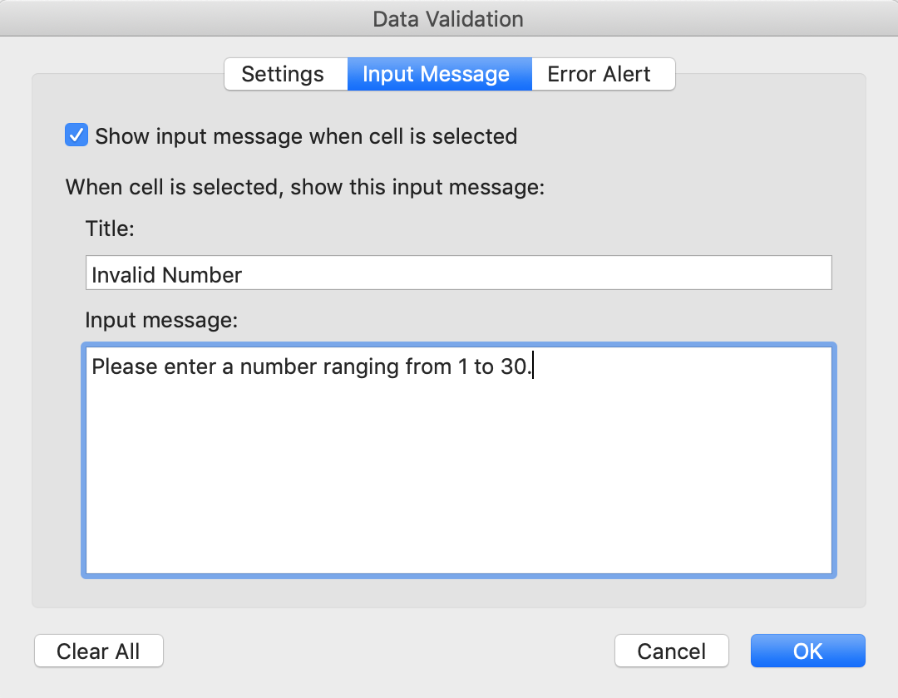

Error: Only when entering the value 50 in cell D133 as instructed by the lesson.

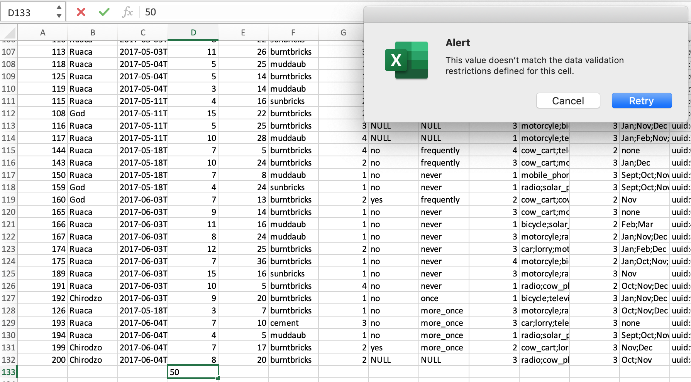

Result: Completed this section of the exercise. I now know how to restrict data entry and change the input message.

**19/8/19 - 12:26pm**

Going on with the exercise, I will now try the Validation with another column in SAFI_clean.xlsx.

Objective: Restrict data entry for the rooms column for values between 1 and 15.

Action:

* Select rooms column.
* Opened the Validation window.
* Allowed > Whole Numbers
* Inputted 1 for Minimum and 15 for Maximum.
* Changed Input Message Title to ‘Invalid Number’.
* Changed messaged to ‘Number must range from 1 to 15’.
* Tested validation by entering 16 into cell G133.
* Tested validation by entering 15 into cell G133.

Error: Error message occurred when entering 16 into G133.

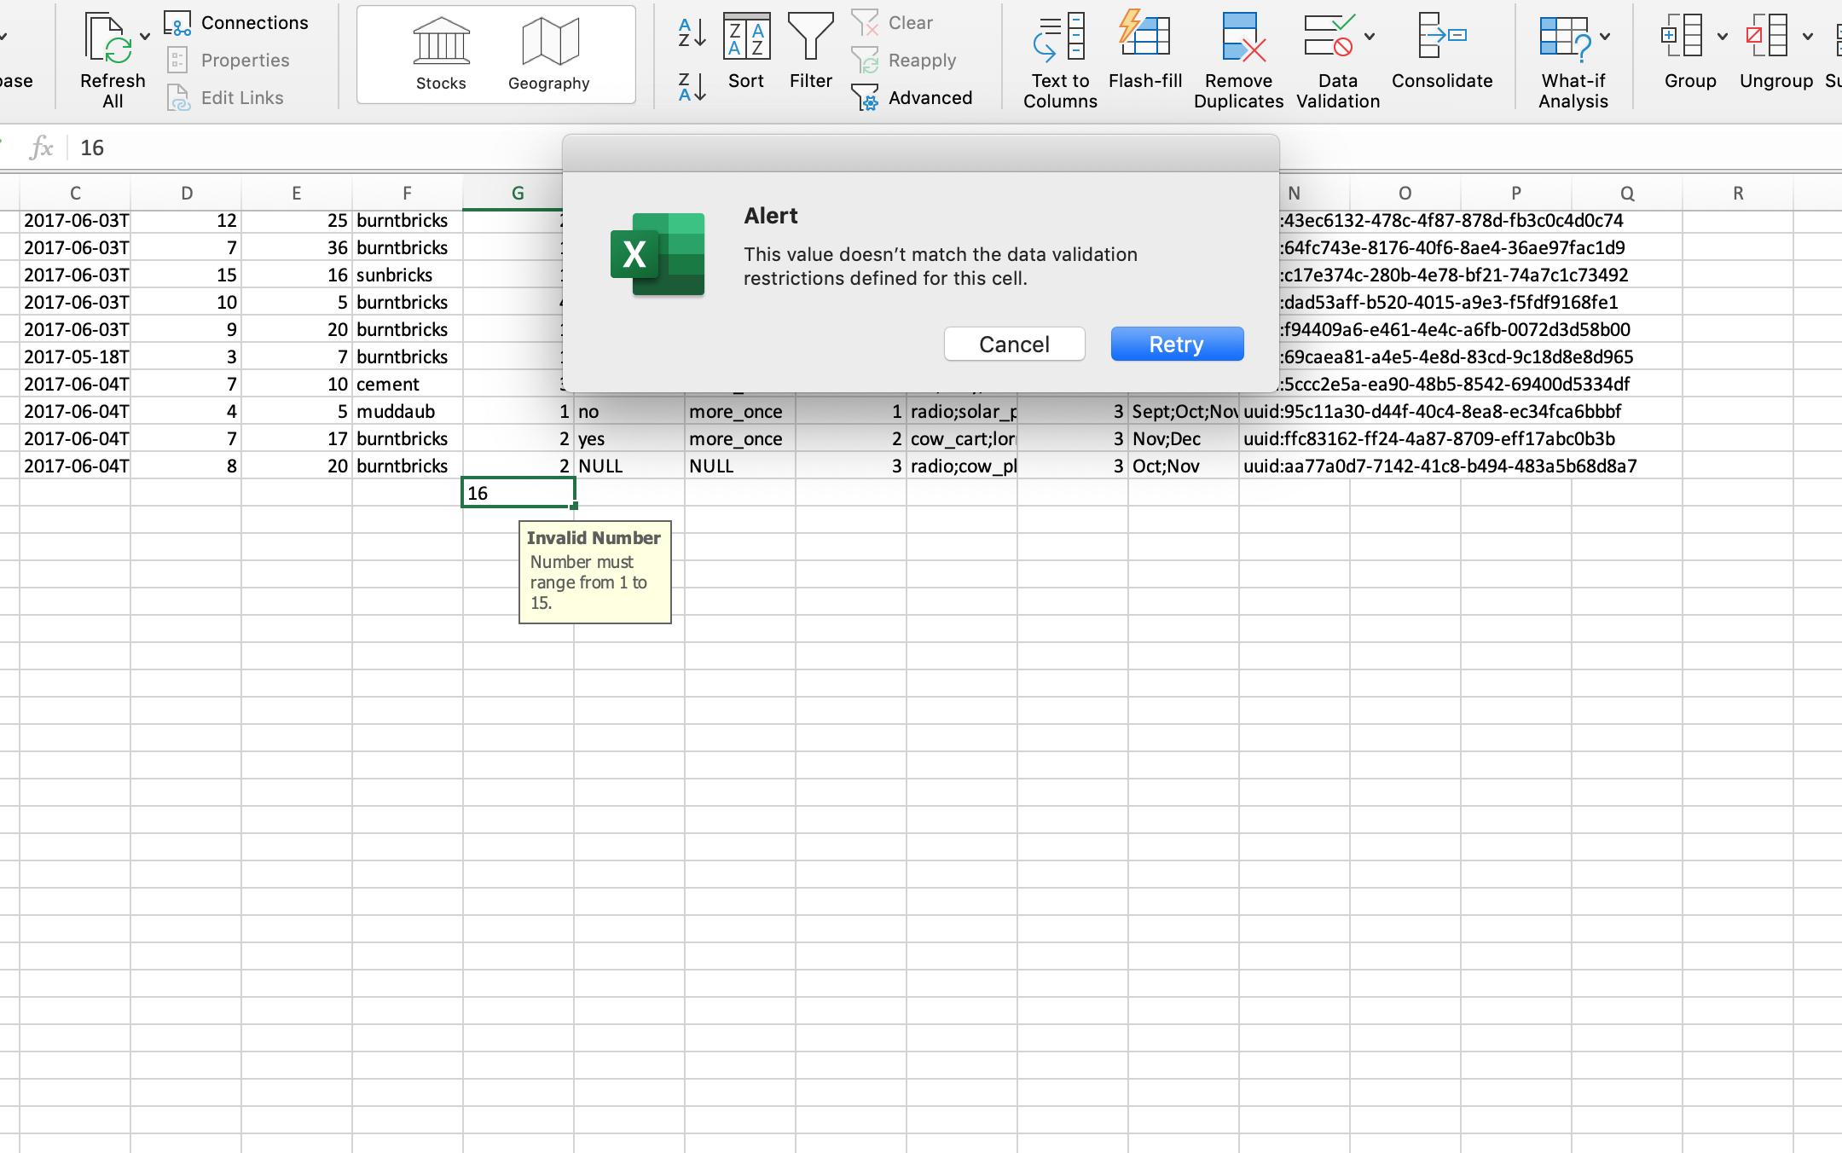

Result: Validation success.

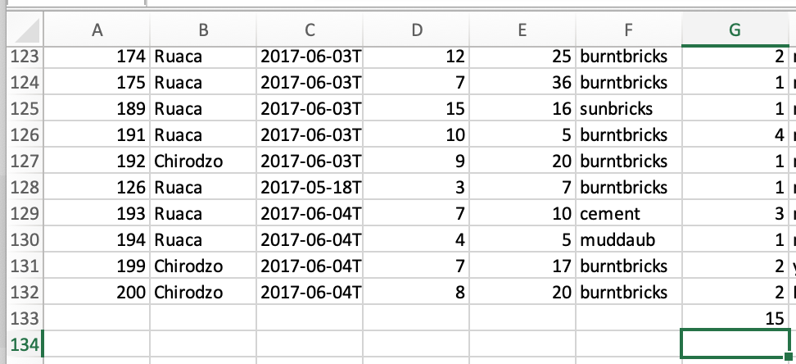

**19/8/19 - 12:44pm**

Will now do the ‘Restricting data to entries from a list’ section.

Objective: Complete ‘Restricting data to entries from a list’ section.

Action:

* Selected respondent_wall_type column.
* Opened the Validation window.
* Selected List from the Allow drop down menu in the Settings tab.
* Entered ‘grass, muddaub, burntbricks, sunbricks, cement’ into the source.
* Entered ‘Only selected items’ for the Input Message Title.
* Entered ‘grass, uddaub, burntbricks, sunbricks, cement’ for the Input Message.
* Clicked OK.

Error: None.

Result: Successfully restricted data entry from a list.

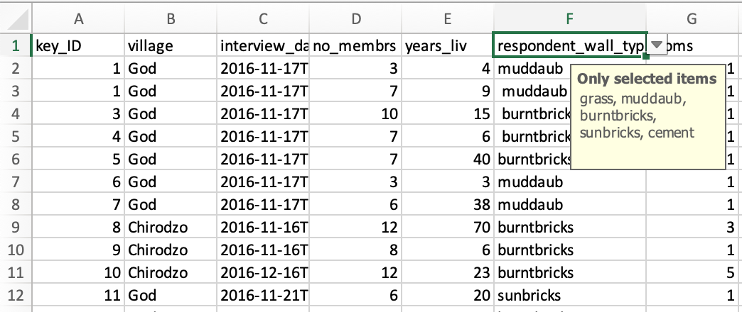

**19/8/19 - 12:52pm**

Now to test the validation.

Objective: Test validation by entering an item not on the list.

Action:

* Entered ‘steel’ in cell F133.
* Entered muddaub in cell F134.

Error: Only when entering ‘steel’ into F133.

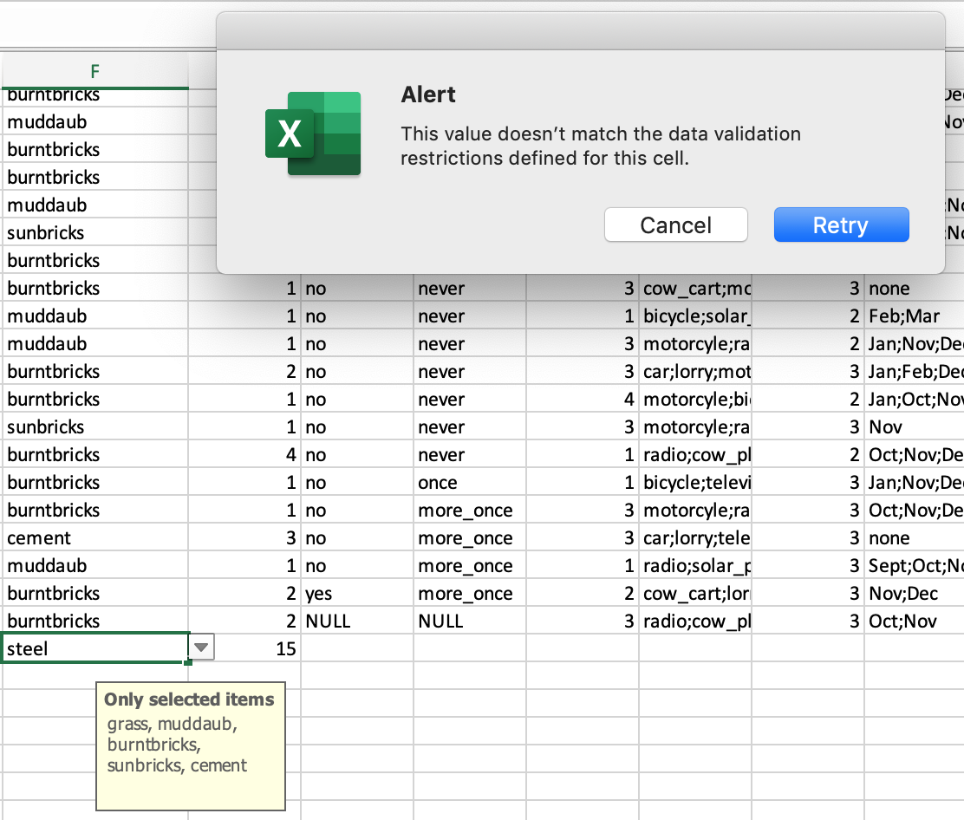

Result: Steel was not accepted, but muddaub was.

**19/8/19 - 12:56pm**

Now I will try to restrict entry to a list for another column.

Objective: Restrict entry for column memb_assoc to only yes, no or NULL.

Action:

* Selected memb_assoc column.
* Opened validation window.
* Selected List from the Allow drop down menu.
* Entered yes, no, NULL to the source.
* Entered ‘Only these items are allowed’ for Input Message Title and ‘yes, no, NULL’ to Input Message.
* Tested validation by entering ‘maybe’ to cell H133.
* Tested valdiation by entering yes to cell H134.

Error: Only when entering ‘maybe’ to cell H133.

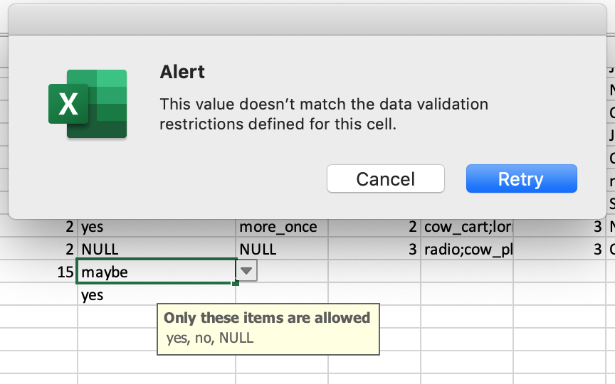

Result: Validation success. Only yes, no or NULL can be entered in the memb_assoc column.

**19/8/19 - 1:08pm**

Just finished reading the Exporting data lesson in Data Carpentry. The big takeaway point is that you should save your data in files that are universal and open. Which means saving data in .xlsx files isn’t a great idea. Instead, use files like .tsv or .csv.

**19/8/19 - 1:09pm**

Objective: Save SAFI_clean.xlsx as SAFI_clean.csv

Action:

* Clicked on File>Save As.
* Selected CSV as the file format.
* Renamed file SAFI_clean_edit.csv because there is an existent SAFI_clean.csv file.
* Clicked save.

Error: None.

Result: Success. Data saved in new SAFI_clean_edit.csv file.

**19/8/19 - 1:12pm**

Objective: Commit SAFI_clean_edit.csv to GitHub.

Action:

* Uploaded SAFI_clean_edit.csv
* Added description ‘SAFI_clean_edit.csv file from Data Carpentry’
* Added extended description ‘This commit contains a file that was made as part of the Data Carpentry Data Organization in Spreadsheets for Social Scientists. It contains work done as part of sections 4, 5 and 6.’
* Selected on Commit changes.

Error: None.

Result: Successfully committed SAFI_clean_edit.csv to GitHub.